**Experiment No. 4**

**Aim:** Create sample application with login module. (Check username and password), validate it for login screen or alert the user with a Toast.

**Program:**

* **Activity.xml :-**

*<?*xml version="1.0" encoding="utf-8"*?>*<RelativeLayout xmlns:android="http://schemas.android.com/apk/res/android"  
 xmlns:app="http://schemas.android.com/apk/res-auto"  
 xmlns:tools="http://schemas.android.com/tools"  
 android:layout_width="match_parent"  
 android:layout_height="match_parent"  
 android:orientation="vertical"  
 android:background="@color/mor"  
 tools:context=".MainActivity">  
  
 <TextView  
 android:layout_width="wrap_content"  
 android:layout_height="wrap_content"  
 android:id="@+id/tv1"  
 android:text="Login Form"  
 android:textStyle="bold"  
 android:textSize="35sp"  
 android:textColor="@color/purple_500"  
 android:layout_centerHorizontal="true"  
 android:layout_marginTop="100dp"/>  
  
 <TextView  
 android:layout_width="wrap_content"  
 android:layout_height="wrap_content"  
 android:id="@+id/tv2"  
 android:text="Name:"  
 android:textSize="20dp"  
 android:layout_marginTop="175dp"/>  
  
 <EditText  
 android:id="@+id/et1"  
 android:layout_width="match_parent"  
 android:layout_height="wrap_content"  
 android:layout_below="@+id/tv1"  
 android:layout_marginLeft="45dp"  
 android:layout_marginTop="15dp"  
 android:layout_toRightOf="@+id/tv2"  
 android:gravity="center"  
 android:hint="Please Enter Your Name"  
 android:minHeight="48dp" />

<TextView  
 android:layout_width="wrap_content"  
 android:layout_height="wrap_content"  
 android:id="@+id/tv3"  
 android:text="Password:"  
 android:textSize="20dp"  
 android:layout_marginTop="235dp"/>

<EditText  
 android:layout_width="match_parent"  
 android:layout_height="wrap_content"  
 android:id="@+id/et2"  
 android:layout_below="@+id/et1"  
 android:layout_marginLeft="15dp"  
 android:layout_marginTop="15dp"  
 android:layout_toRightOf="@+id/tv3"  
 android:gravity="center"  
 android:hint="Please Enter Your Password"  
 android:inputType="textPassword"  
 android:minHeight="48dp"/>

<Button  
 android:id="@+id/log"  
 android:layout_width="wrap_content"  
 android:layout_height="wrap_content"  
 android:layout_marginTop="35dp"  
 android:padding="13dp"  
 android:layout_marginLeft="175dp"  
 android:layout_below="@+id/et2"  
 android:text="Login"  
 android:onClick="Login"  
 />  
</RelativeLayout>

* **colors.xml :-**

*<?*xml version="1.0" encoding="utf-8"*?>*<resources>  
 <color name="purple_200">#FFBB86FC</color>  
 <color name="purple_500">#FF6200EE</color>  
 <color name="purple_700">#FF3700B3</color>  
 <color name="teal_200">#FF03DAC5</color>  
 <color name="teal_700">#FF018786</color>  
 <color name="black">#FF000000</color>  
 <color name="white">#FFFFFFFF</color>  
 <color name="mor">#08E3FF</color>  
</resources>

* **MainActivity.java :-**

package com.example.login;  
  
import static com.example.login.R.id.*log*;  
  
import androidx.appcompat.app.AppCompatActivity;  
  
import android.os.Bundle;  
import android.view.View;  
import android.widget.Button;  
import android.widget.EditText;  
import android.widget.Toast;  
  
public class MainActivity extends AppCompatActivity {  
 EditText ed1, ed2;  
 Button bt;  
 String uname, upass;  
 @Override  
 protected void onCreate(Bundle savedInstanceState) {  
 super.onCreate(savedInstanceState);  
 setContentView(R.layout.*activity_main*);  
 ed1 = findViewById(R.id.*et1*);  
 ed2 = findViewById(R.id.*et2*);  
 bt = findViewById(R.id.*log*);  
 }  
  
 public void Login(View view) {  
 uname = ed1.getText().toString();  
 upass = ed2.getText().toString();  
 if (uname.equals("Manish") && upass.equals("2809")){  
 Toast.*makeText*(this, "LOGIN SUCCESSFUL", Toast.*LENGTH_SHORT*).show();  
 }  
 else {  
 Toast.*makeText*(this, "LOGIN FAILED", Toast.*LENGTH_SHORT*).show();  
 }  
 }  
}

**Output:**

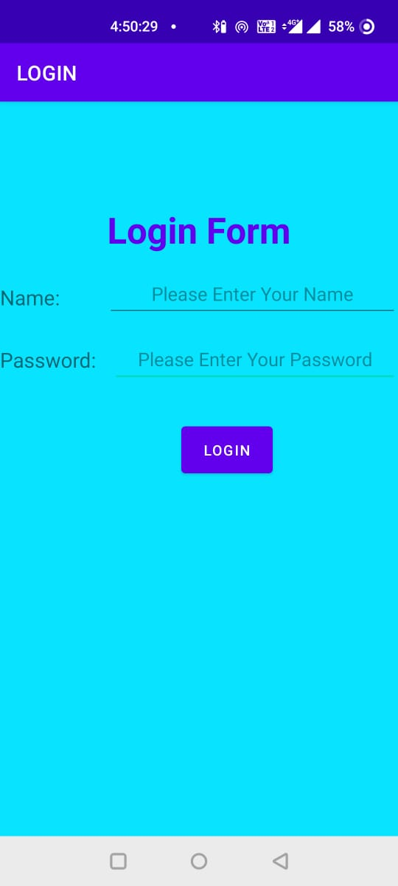 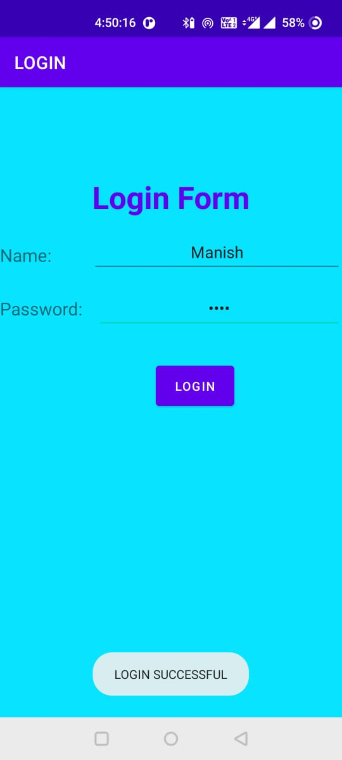

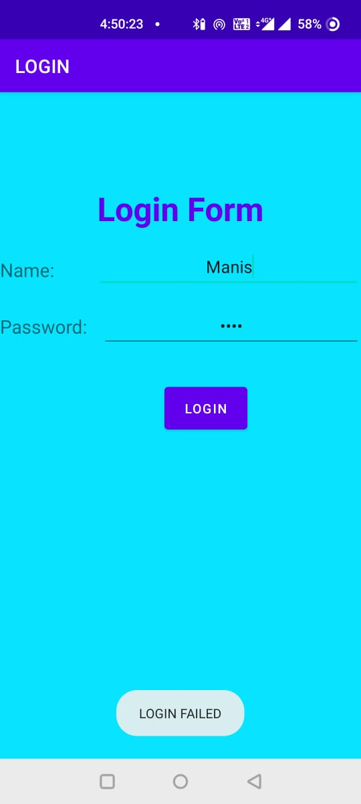



**Conclusion:**

Hence, by completing this experiment I came to know that how to Create application for demonstration of android activity life cycle.

|  |  |  |  |
| --- | --- | --- | --- |
| **Writeup & Oral**  **(4)** | **Practical Performance**  **(4)** | **Attendance**  **(2)** | **Total**  **(10)** |
|  |  |  |  |